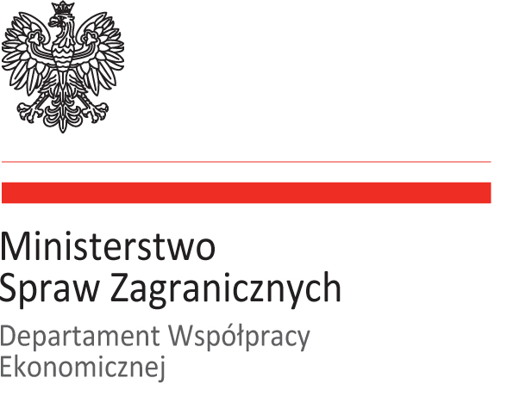

Prosimy o odesłanie formularza wypełnionego w języku angielskim
do dnia 24 maja 2018 r. na adres: daniel.piekarski@msz.gov.pl

Company/Institution full name
Representatives |  | Position/Current occupation | Contact details (phone, e-mail, www)
1.
2.
Company profile
Maximum 200 words - including sector, location, level of employment, open financial information This can include brief general info on company main business areas, years of operation, customer base. This high level, introductory information can come directly from your website or descriptive brochure sources. Please do not simply state “See website”

Your Core Technology and/or Capability
Maximum 200 words – Describe your Core Technology or Technologies

Your Technology and/or Key Discriminators/Competitive Advantages
Maximum 200 words – What makes you stand out above your competition? Any information that helps to quantify or qualify the discriminators, in a non-proprietary way, is useful. Patents or intellectual property could be identified here. This section is perhaps the first section at which our reviewers look. i.e. the product or technology the company is offering for consideration represents original ideas wholly owned with freedom to use

The Value You Believe You Bring to Boeing
Maximum 200 words – This can include application areas in aerospace, defense or other sectors that may be of interest to Boeing, and ideas on how this technology or relation in your view could help Boeing

Previous experience with international & local companies or customers (if appropriate list)
Maximum 200 words – including names/branches, countries/regions, scopes, estimated project turnovers

Certifications, approvals, credentials, etc.
Maximum 200 words - list including- i.e. quality, security, finances, intellectual property etc.

Potential fields of cooperation with Boeing (http://www.boeing.com/)
Maximum 200 words – including potential projects/solutions, added value for Boeing etc., focus areas and key themes i.e. aerospace, space & satellites, IT (including IoT, AI, Big Data) specific fields/areas/solutions/technologies if possible

Research & Development experience (if applicable & allowable)
Maximum 200 words

